Getting Started with Bee Bots
What are Bee Bots?
Bee Bots are programmable floor robots that have been purpose-built for use with early elementary students. Bee Bots can move on any flat surface including carpet, tiles, concrete, plastic, cardboard and wood. Bee Bots can also move up slight inclines.
- Bee Bot has bright buttons for students to use to input instructions.
- Bee Bot moves accurately in 15cm steps and turns in 90 degree increments.
- Bee Bot remembers up to 40 instructions / steps entered by students.
- Sounds and flashing eyes let students know that their instructions have been entered.
Operating the Bee Bot
Turn the Bee Bot on with the small black switch underneath.
Sound is optional; that’s the second switch.
Program using the buttons on the back:

forward 15cm
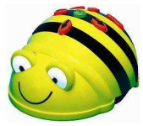
Photo Credit http://codigo21.educacion.navarra.es/wp-content/uploads/2015/09/BeebotguideA4v2.pdf
backward 15cm
turn right 90⁰
turn left 90⁰
clear the memory
pause
run the program
Using the Bee Bot Mat:
Living and Non-Living Things
Learning Objective:
Identify living and non-living things.
Plan and predict the behavior of simple programs.
Activity: Plugged
Working in collaborative groups, students will take turns programming the Bee Bot to travel to and stop on all of the living or non-living objects on the card mat.

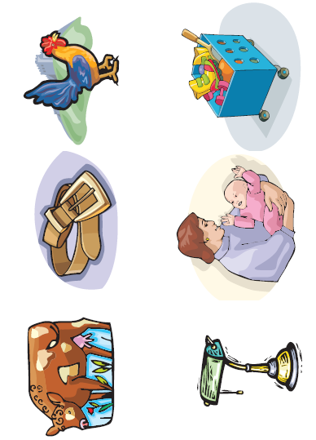

More ideas for Science . . .
- Phases of the Moon
- Plants
- Weather
- Body Parts
- Our Five Senses
- States of Matter
and so much more!

Using the Bee Bot Mat:
Ten Frames, Dot Cards and Addition, Oh My!
Learning Objective:
Identify multiple representations of numbers.
Add within 20.
Plan and predict the behavior of simple programs.
Activity: Plugged
Students will identify the value or sum given on their card by navigating Bee Bot to the correct number on the card mat.
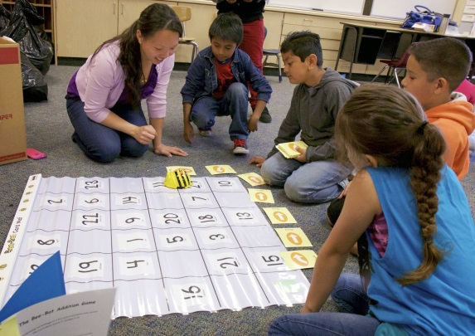
Photo Credit http://4.bp.blogspot.com/-lpsjysVEykA/VSWwTx48DYI/AAAAAAAABxw/BruwzBCgyBw/s1600/IMG_1830.jpg

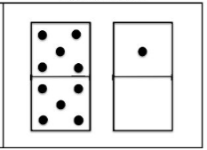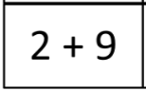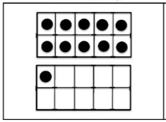

More ideas for Math . . .
- One More, One Less
- Ten More, Ten Less
- Counting Money
- Geometric Shapes
- Ways to Make 10
- Missing Addends
and so much more!
Using the Bee Bot Mat:
Problem Solving Challenges
Learning Objectives:
Understand that a computer follows precise commands and will respond to those commands consistently.
Plan and predict the behavior of simple programs.
Activity: Plugged
Provide students a route Bee Bot should travel.

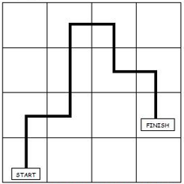
Working in collaborative groups, students should use command cards to map out the steps Bee Bot must take.

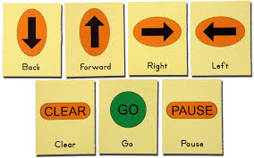

Students then test their program on the mat.

Help! I’m Stuck!  Place command cards on the card mat to build the route. | Need a challenge!  What next?  Students plan their own route and ask another group to test their program. Does everyone end up at the same place?
Playing & Exploring Bee Bot:
How Far?
Learning Objectives:
Use non-standard units of measure.
Predict the behavior of simple programs.
Activity: Plugged
For this activity, children explore how far Bee-Bot can travel in one step.

Students will explore how concrete materials may be used as non-standard units of measure. For example, students will estimate and then investigate how many Lego Bricks, counters or paperclips are needed to represent how far a Bee Bot moves with each step.
A key part of this activity is the discussion that should take place during the culminating stage. During this discussion, students should be asked to share their findings and make comparisons relating to the types of non-standard units used.
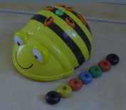

For example, the students might have discovered that a Bee-Bot moves the length of six paperclips or four blocks.
Help! I’m Stuck!  Think about how you mark the start and end. | Need a challenge!  What next?  This can then provide a starting point to explore standard units of measure and the use of rulers and measuring tapes.

Playing & Exploring Bee Bot:
Trails
Learning Objectives:
Use standard units of measure.
Predict the behavior of simple programs.
Activity: Plugged
Take students outside where sidewalk chalk can be used to draw a trail for Bee Bot to travel.

Model how to design a Bee Bot trail from a starting point to a target such as a flower.
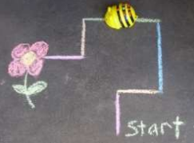

Emphasize the importance of measuring the trail to ensure the Bee Bot can reach and turn at particular points.

Working in collaborative groups, students use a tape measure or ruler to design their trail. Students then write and test a program to have Bee Bot navigate the trail.
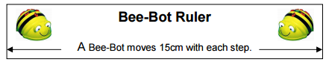
Help! I’m Stuck!  For children who are not yet ready to use standard rulers or measuring tapes, provide 15 cm Bee Bot rulers. | Need a challenge!  What next?  Can children design a circular route to get Bee-Bot back home?

Playing & Exploring Bee Bot:
The Little Bee Bot That Could
Learning Objective:
Compare the effects of different strengths of pushes and pulls on the motion of an object.
Predict the behavior of simple programs.
Activity: Plugged
Students will attach string to the tow bar on the back of the Bee Bot to enable the bot to tow other objects.

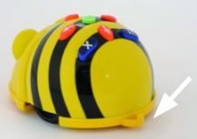
Students will investigate the different loads that Bee Bots can tow and how the weight of the load affects the distance the Bee Bot travels in each step.

Teachers may use the text The Little Engine that Could as a stimulus for this activity. Students could then collaboratively develop a class book of their own, The Little Bee Bot That Could, using digital photographs of the students experimenting with different loads to illustrate the text.

Help! I’m Stuck!  Work with students in small groups to model how to vary the load and record the distances Bee Bot travels when towing each load. | Need a challenge!  What next?  Provide students experiences that illustrate the connection between the distance Bee Bot travels in each step and the speed at which the robot travels.

Playing & Exploring Bee Bot:
Surfaces
Learning Objective:
Investigate how different surfaces affect the movement of an object.
Predict the behavior of simple programs.
Activity: Plugged
Identify some different surfaces to try.
- tiles
- carpet
- concrete
- grass
- plastic
- cardboard
- wood

Students will predict on which surface they believe Bee Bot will function and move the best.

After investigating Bee Bot’s movement on each surface, students will answer and discuss the following questions.
- On which surface does Bee-Bot work best?
- How do you know?
- Why is this?
- Does everyone agree?
Help! I’m Stuck!  Limit the number of surfaces to be tested as needed to address student readiness. | Need a challenge!  What next?  Set up some experiments with different inclines for Bee-bot to travel up and down.

